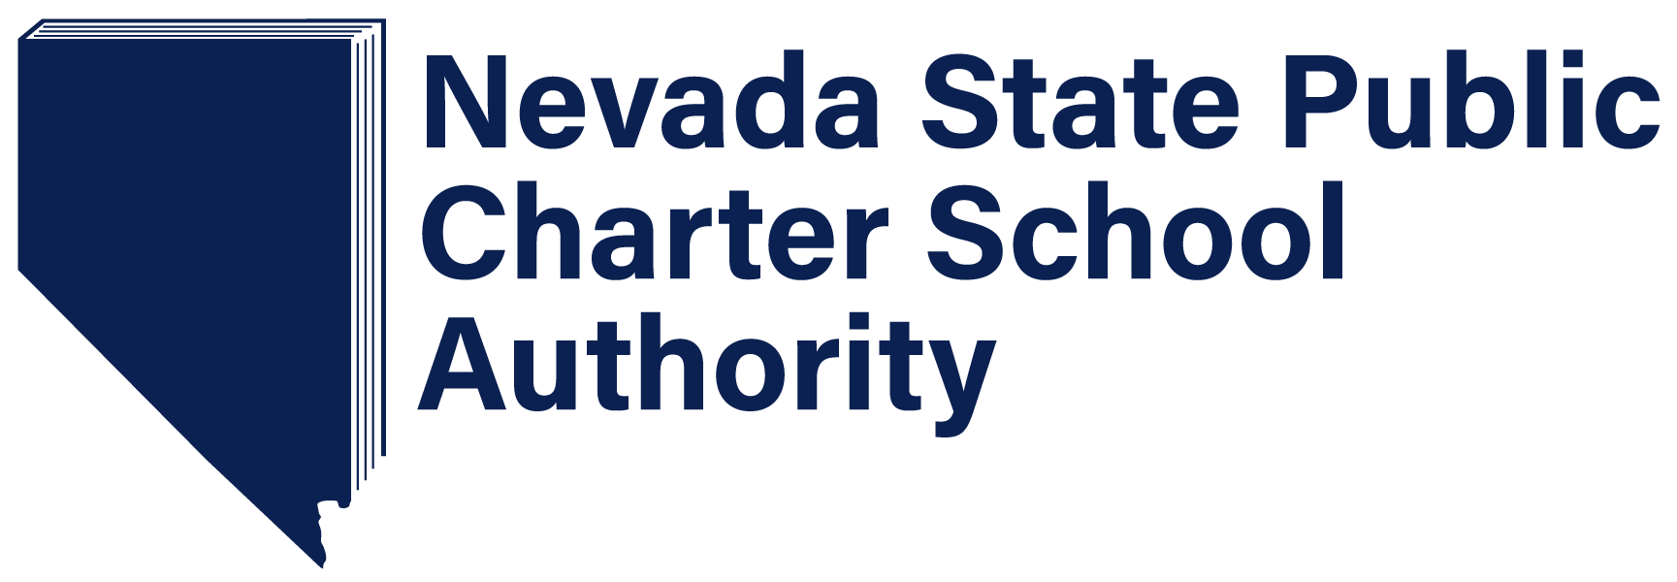

2018 Application for the Renewal of a Charter Contract

For Schools Not Determined to be Eligible for Expedited Renewal

CHARTER SCHOOL RENEWAL APPLICATION AND GUIDELINES

Per Nevada Revised Statute 388A.285, charter school authorizers are responsible for evaluating current charter schools’ performance and achievement levels in the process of deciding whether to renew a school’s charter. A strong renewal process is critical to protect charter school autonomy, students, and stakeholders and ensures schools are held to high standards.

In the following pages, we provide guidance around and outline the timeline for the renewal process with the hopes of making the process as seamless and smooth for schools and our Authorization team.

Please read through the renewal application and guideline carefully and reach out to Mark Modrcin, Director of Authorization at 702.486.8271 or mmodrcin@spcsa.nv.gov, with any questions.

All of us at the Nevada State Public Charter School Authority are excited to work with each of you and support the work schools are doing on behalf of Nevada students.

RENEWAL TIMELINE

Renewal Stage | Date | Action
Letter of Intent | Released in August | SPCSA releases form and guidance to schools who are up for renewal.
Letter of Intent | Due by Sept 1 | Schools complete this critical first step and submit notice of intent to apply for charter renewal. Schools submit letters to EpiCenter,
Release of renewal application and decision criteria | Released by August 31 | SPCSA releases the renewal application via Authority website and email to schools who are up for renewal.
Release of renewal application and decision criteria | Due by October 15 @ 5 p.m. | Schools complete the formal renewal application process, submitting required documents and evidence to support a renewal. Schools submit renewal applications to EpiCenter.
Renewal Orientation  (optional) | Early/Mid- September | Schools up for renewal will be invited to join an optional orientation to answer general questions, address common concerns, and learn more about the renewal process.
Staff Review | Mid-October through mid-November | Staff reviews schools’ applications and supporting documents, which may include any previously conducted site evaluations, to provide an informed, evidence-based recommendation to SPCSA Board.
Staff Recommendation | November – December, or mutually agreed upon date | Staff submits recommendation to SPCSA Board based on thorough review.  Staff will provide a copy of the recommendation to the school, and the school will have 5 days to submit a rebuttal. Rebuttals will become part of the public record, if submitted.
Board Decision | November – December, or mutually agreed upon date | Based on staff recommendation, the Board will discuss and make decision about schools’ renewals

REQUIRED SUBMISSIONS
The completed renewal application and all required documents must be submitted as a Word document and a signed PDF into the Charter Renewal Application section in Epicenter by 5 pm PT on the due date.

Renewal Application
Complete the provided template application for the following:
- Academic Performance
- Operational Overview
- Financial Performance
- Organizational Performance
- Next Charter Term

OVERSIGHT
Renewal decisions for schools operating under written charters are based on historic performance data as evidenced by the SPCSA Performance Framework, which serves as the Authority’s performance and programmatic audit mechanism for all schools operating under written charters. Historical anecdotes or unsolicited data, e.g. teacher turnover, leadership changes, or past programmatic adjustments, will not be considered by the Authority in making renewal decisions. The Board will not give weight to materials or testimony related to such topics during the renewal process. The inclusion of unsolicited data, supplementary narratives, letters of support, or other unsolicited materials will result in the return of the renewal application and a request for resubmission of a compliant and complete application from SPCSA staff.

Schools which are contemplating material amendments, e.g. changes to the mission statement, grade levels served, enrollment, facilities expansion, academic program, instructional delivery, management agreement, etc. will be permitted to submit such amendment requests in the event that the school is renewed based on past performance. Schools are permitted to draft such amendment requests during the renewal process for filing immediately following the renewal decision but the SPCSA Board will not give weight to such materials or testimony related to any contemplated changes during the renewal process. The inclusion of amendment materials will result in the return of the renewal application and a request for resubmission of a compliant and complete application from SPCSA staff.

It is the responsibility of the school to ensure that the content is accurate and reflects information provided by NDE and the SPCSA. Any discrepancies between the data submitted and data previously provided by NDE or the SPCSA will result in a request for resubmission of a compliant and complete application from SPCSA staff.

Schools are required to submit the agenda and draft minutes for the meeting where the governing body voted to approve the submission of the renewal application into the appropriate areas in Epicenter prior to filing the renewal application. Failure to submit the agenda and draft minutes into the appropriate areas in Epicenter prior to filing the renewal application will result in the return of the renewal application and a request for resubmission of a compliant and complete application from SPCSA staff. The inclusion of the agenda and draft minutes with the renewal application will result in the return of the renewal application and a request for resubmission of a compliant and complete application from SPCSA staff.

Accessibility to Individuals with Disabilities
All Charter School applications and renewals are required to be ADA Compliant as described by Section 508 Rehabilitation Act of 1973 (refer to 29 U.S.C. 794d). This statute requires access to and use of Federal executive agencies’ electronic and information technology (ICT) by individuals with disabilities. Compliance with Section 508 is mandatory for all entities receiving federal funds--including the SPCSA and its charters.

2018 Application for Renewal of Charter

School Name & Contact Info | Name:  Address:  Phone:  Website:
School Leader Name & Contact Info | Name:  Title:  Office Phone:  Email:

ACADEMIC PERFORMANCE
2018 NSPF Rating |  |  |  |  | Elementary: Choose an item.  Middle: Choose an item.  High School: Choose an item.
2018 Rising Star Status |  |  |  |  | Choose an item.
2017 NSPF Rating |  |  |  |  | Elementary: Choose an item.  Middle: Choose an item.  High School: Choose an item.
2017 Rising Star Status |  |  |  |  | Choose an item.
2017 Elementary School Percentage in State |  |  |  |  | Choose an item.
2017 Middle School Percentage in State |  |  |  |  | Choose an item.
2016 Rising Star Status |  |  |  |  | Choose an item.
2016 Elementary School Percentage in State |  |  |  |  | Choose an item.
2016 Middle School Percentage in State |  |  |  |  | Choose an item.
2015 Rising Star Status |  |  |  |  | Choose an item.
2015 Elementary School Percentage in State |  |  |  |  | Choose an item.
2015 Middle School Percentage in State |  |  |  |  | Choose an item.
2014 SPCSA Academic Programmatic Audit Findings (SPCSA Academic Performance Framework Rating) |  |  |  |  | Choose an item.
2014 Academic Intervention Ladder Status |  |  |  |  | Choose an item.
2013 SPCSA Academic Programmatic Audit Findings (SPCSA Academic Performance Framework Rating) |  |  |  |  | Choose an item.
2013 Academic Intervention Ladder Status |  |  |  |  | Choose an item.
2015 NSPF Rating (Frozen from 2014) |  |  |  |  | Elementary: Choose an item.  Middle: Choose an item.  High School: Choose an item.
2014 NSPF Rating |  |  |  |  | Elementary: Choose an item.  Middle: Choose an item.  High School: Choose an item.
2013 NSPF Rating |  |  |  |  | Elementary: Choose an item.  Middle: Choose an item.  High School: Choose an item.
2012 NSPF Rating |  |  |  |  | Elementary: Choose an item.  Middle: Choose an item.  High School: Choose an item.
 | 2012-13 | 2013-14 | 2014-15 | 2015-16 |  | 2016-17
NDE-Validated Graduation Rate | Click here to enter text. Use whole numbers only. | Click here to enter text. Use whole numbers only. | Click here to enter text. Use whole numbers only. | Click here to enter text. Use whole numbers only. |  | Click here to enter text. Use whole numbers only.

OPERATIONAL OVERVIEW
Current Year Enrollment & Demographic Details
Number of Students on Waitlist | Percentage of Waitlist Students w/Preference Status | Number of Instructional Staff | Total Number of Staff
Total Student Enrollment (as of October 1, 2018 or Validation Day

FINANCIAL PERFORMANCE
SPCSA Financial Programmatic Audit Findings
2017 | Choose an item.
2016 | Choose an item.
2015 | Choose an item.
2014 | Choose an item.
2013 | Choose an item.

ORGANIZATIONAL PERFORMANCE
SPCSA Organizational Programmatic Audit Findings
2017 | Choose an item.
2016 | Choose an item.
2015 | Choose an item.
2014 | Choose an item.
2013 | Choose an item.

NEXT CHARTER TERM
Projected Enrollment & Grade Spans for next charter term (pending any subsequent expansion amendment that requires Authority Board approval)

 | 2019-2020 | 2020-2021 | 2021-22 | 2022-23 | 2023-24 | 2024-2025
Planned Total Enrollment
Kindergarten
1st grade
2nd grade
3rd grade
4th grade
5th grade
6th grade
7th grade
8th grade
9th grade
10th grade
11th grade
12th grade

I certify that the governing body of this charter school has voted that the school and its staff will adhere to the renewal process expectations outlined in the Renewal Guidelines. The information provided in this charter renewal application is true and correct. I also certify that the governing body of this charter school understands that any academic, financial, or organizational performance data collected during the period of the current charter term which is analyzed and reported following a renewal vote may be considered by the Authority in making performance and accountability decisions in the subsequent charter term.

Signature of Head of School:
Date:

Signature of President/Chair of Governing Body:
Date Governing Body voted to approve application for renewal:
Name of Chair:
Email of Chair:
Cell Phone of Chair:
Work Phone of Chair:

Governing Board Information & Signature of Support for Renewal Application
 | Contact Info | Signature of Support for Renewal Application
Vice Chair/Vice President | Name:  Email:  Cell Phone:  Work Phone:
Treasurer | Name:  Email:  Cell Phone:  Work Phone:
Secretary | Name:  Email:  Cell Phone:  Work Phone:
Member | Name:  Email:  Cell Phone:  Work Phone:
Member | Name:  Email:  Cell Phone:  Work Phone:
Member | Name:  Email:  Cell Phone:  Work Phone:
Add rows for additional board members as needed.

