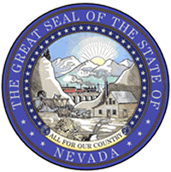
Nevada State Public Charter School Authority
Public Records Request
Deliver, Mail, Email or Fax to: Public Records Officer
2080 East Flamingo Road #230
Las Vegas, NV 89119
FAX: 702-486-5543 publicinformation@spcsa.nv.gov

Date of Request
Requestor Contact Information
Name:
Organization:
Address:
City, State, Zip:
Phone:
E-mail:

Records Requested:
Check one: Paper copies Electronic copies Certified copies Inspection (in person)
Please be specific and include as much detail as possible regarding the records you are requesting.

To complete an estimate, the agency will need the following information:
I will pick up | Please FedEx  Fed Ex billing number: | Please send USPS | E-mail (if format allows)

Statement
I understand there is a charge for copies of public records. I understand I will receive a written estimate for production of the records indicated above if the estimated cost is expected to be over $10.00, which I will be required to pay in full prior to inspection or reproduction. Materials will be held for 30 days.
Requester  Signature | Signature

Office Use Only

Request status: |  |  |  | Estimate:
 | Date | Request received |  | Estimate: | $
 |  | Receipt acknowledgement issued |  | Date deposit received
 |  | Request filled |  | Actual (if different): | $
 |  | Estimated completion |  | Date final payment received
 |  | Estimate provided |  | Completed by
 |  | Request denied in whole
 |  | Other: |  | Retain request form for 90 days following completing of request. RDA 2009047

